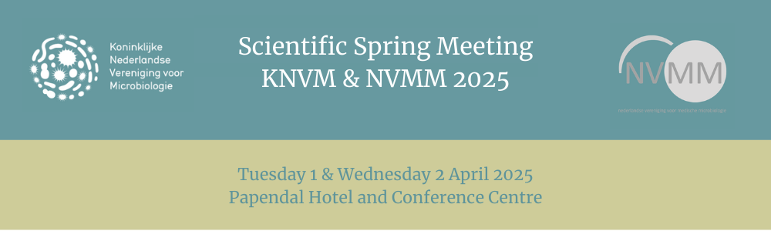

**REGISTRATION NOW OPEN, Keynote speakers**

**and Reminder Award deadlines**

**Register now!**

Save your spot and register now for the Scientific Spring Meeting KNVM NVMM 2025.  
More information on the fees and to register can be found [HERE](https://www.scientificspringmeeting.nl/registration/).

**Keynote speakers**

We are delighted to announce the keynote speakers: Chris Chiu, John Cryan, Martin Kaltenpoth and Robin Patel. In this newsletter you can read more about the background of two of them:

**John Cryan**

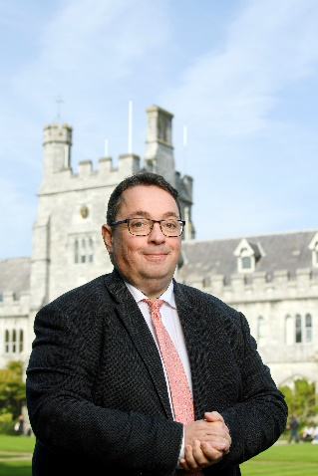John F. Cryan is Professor & Chair, Dept. of Anatomy & Neuroscience, University College Cork where he also serves as Vice President for Research & Innovation since 2021.  He is also a Principal Investigator in the APC Microbiome Ireland Institute. Prof. Cryan's current research is focused on understanding the interaction between brain, gut & microbiome and how it applies to stress, psychiatric and immune-related disorders at key time-windows across the lifespan. Prof. Cryan has published over 700 peer-reviewed articles and book chapters and has a H-index of 168(Google Scholar). He has co-edited four books and is co-author of the bestselling “*The Psychobiotic Revolution: Mood, Food, and the New Science of the Gut-Brain Connection*”. He has received numerous awards including UCC Researcher of the Year in 2012,  the University of Utrecht Award for Excellence in Pharmaceutical Research in 2013, UCC Research Communicator of the Year 2017, and being named on the Thomson Reuters/Clarivate Highly Cited Researcher list in 2014 and each year from 2017 to the present. He was elected a Member of the Royal Irish Academy in 2017 . He also received a Research Mentor Award from the American Gastroenterology Association and the Tom Connor Distinguished Scientist Award from Neuroscience Ireland in 2017 and was awarded an honorary degree from the University of Antwerp, Belgium in 2018. He was a TEDMED & TEDx speaker and is a Past-President of the European Behavioural Pharmacology Society.

**Robin Patel**  
Robin Patel is the Elizabeth P. and Robert E. Allen Professor of Individualized Medicine and the Director of the Infectious Diseases Research Laboratory, Co-Director of the Clinical Bacteriology Laboratory, Vice Chair of Education in the Department of Laboratory Medicine and Pathology, and former Chair of the Division of Clinical Microbiology, at the Mayo Clinic. Since the beginning of her tenure at the Mayo Clinic, Dr. Patel has focused her research on bacterial infections. Her work focuses on three major areas: (1) improvement of next-generation diagnostic techniques for infectious diseases, (2) understanding the inherent biology of periprosthetic infection, and (3) understanding antibiotic resistance through a clinical lens. She has published over 635 peer-reviewed publications and is supported by the National Institutes of Health and the Centers for Disease Control and Prevention. She is the Director of the Laboratory Center of the Antibacterial Resistance Leadership Group of the National Institutes of Health.

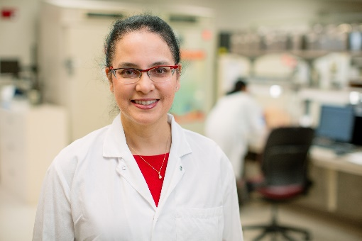Dr. Patel received an undergraduate degree in Chemistry from Princeton University, where she graduated *magna cum laude*. From there, she obtained a medical degree from McGill University. Afterwards, Dr. Patel completed Internal Medicine Residency and Fellowships in Medical Microbiology and Infectious Diseases at the Mayo Clinic. Since then, she has been involved in setting standards for diagnostic and clinical care of bacterial infections, as evidenced by the (select) positions she has held or holds within the American Society for Microbiology (President, Secretary), American Board of Pathology (Microbiology Test Writing Committee Member), Clinical and Laboratory Standards Institute (Subcommittee on Antimicrobial Susceptibility Testing Voting Member), National Institutes of Allergy and Infectious Diseases (Council Member), National Board of Medical Examiners (Microbiology/Immunology Test Material Development Committee Chair), Journal of Clinical Microbiology (Associate Editor), Clinical Infectious Diseases (Associate Editor) and the Presidential Advisory Council on Combating Antibiotic-Resistant Bacteria (Voting Member).

In addition, Dr. Patel’s continued commitment to mentorship can be translated into a long list of trainees from around the world; she had dedicated hours of teaching to train the next generation of clinical and research laboratory scientists.

Discover [HERE](https://www.scientificspringmeeting.nl/programme/?tab=1) the preliminary programme and register now.

**Reminder Award deadlines: 15 January 2025**  
**PhD Thesis Fund**

The KNVM/NVMM science committee provides financial support for publishing PhD-theses in the field of microbiology. Funding was initiated in 2009, and follows a “first come, first serve” principle. The PhD candidate must be an active member of the KNVM/NVMM as evidenced by for example membership or previous presentations at KNVM/NVMM meetings. Support is now available for all submitted theses for an award of € 250. Click [here](https://www.nvmm.nl/media/1043/proefschriftenfonds_2015_0.pdf) for the conditions. ​Submissions can be sent to [secretariaat@nvmm.nl](mailto:secretariaat@nvmm.nl)

**Submission deadline: 15 January 2025**

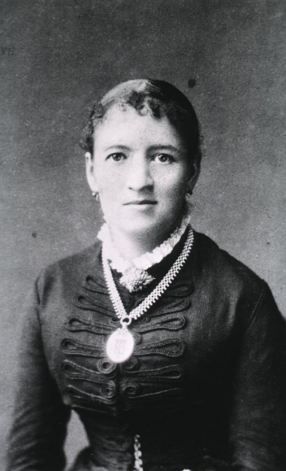**Fanny Hesse Award  
De KNVM reikt drie prijzen uit voor de beste HBO-bachelor scripties op het gebied van de microbiologie in de breedste zin van het woord. De kandidaten, studenten van Nederlandse hogescholen, worden gevraagd hun bachelor scriptie, die is beoordeeld in het voorgaande jaar, in te zenden met een korte aanbeveling van hun begeleider. De prijzen worden uitgereikt tijdens de BaMa-sessie van de Scientific Spring Meeting van de KNVM/NVMM. De jury bestaat uit leden van het KNVM-bestuur. Stuur je inzending naar** [**secretariaat@knvm.org**](mailto:secretariaat@KNVM.org) **(deadline 15 februari 2025).**

The KNVM awards three prizes for the best applied sciences bachelor’s theses in the field of microbiology, in the broadest sense. Candidates, who are students from Dutch universities of applied sciences, are invited to submit their bachelor’s thesis, which was assessed in the previous year, along with a brief recommendation from their supervisor. The prizes are awarded during the Bachelor-Master session of the KNVM/NVMM Scientific Spring Meeting. The jury consists of members of the KNVM board. Send your submission to [secretariaat@knvm.org](mailto:secretariaat@knvm.org)   
**Submission deadline: 15 February 2025**

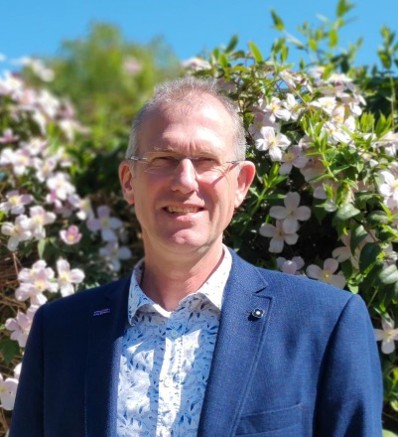**Mike Jetten Award (Master thesis prize)**

The KNVM will award three prizes for the best master theses in the field of microbiology in the broadest sense. The candidates, students from Dutch universities, are encouraged to submit their master thesis with a short recommendation from their supervisor. The three prizes are awarded during the KNVM/NVMM Scientific Spring Meeting. The jury consists of members of the KNVM board. All Master theses graded in the calendar year preceding the Scientific Spring Meeting in which the prize will be awarded are eligible. Please send your submission to: [secretariaat@knvm.org](mailto:secretariaat@KNVM.org)  
**Submission deadline: 15 January 2025**

**Kluyver award**  
The KNVM board makes the Albert Kluyver award available to microbiologists (in any field, but currently employed at Dutch institutions) with an outstanding contribution to microbiology within eight years after obtaining their PhD (the NWO extension rules apply). This contribution may be a combination of scientific, educational, and/or (public) outreach achievements. The prize - awarded during the KNVM/NVMM Scientific Spring Meeting - has on average been awarded once every three years between 1963 and 2010, sponsored by DSM. As of 2024, the award will be on behalf of the KNVM and will be awarded once every year. The awardee will be asked to give a short presentation on their work at the KNVM/NVMM Scientific Spring Meeting and is expected to be(come) a member of the KNVM.

To nominate a candidate, please send a letter of support explaining why the candidate should be considered for this award and a CV or resumé of the candidate to [secretariaat@knvm.org](mailto:secretariaat@KNVM.org).

**Submission deadline: 15 January 2025**

**More information:** [**www.scientificspringmeeting.nl**](http://www.scientificspringmeeting.nl)