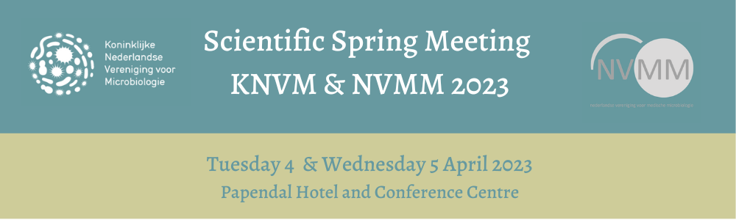
REGISTRATION OPEN, CALL FOR ABSTRACTS & MIKE JETTEN AWARD

Registration now open!
It is now possible to register for the Scientific Spring Meeting KNVM NVMM 2023.
More information on the fees and to register can be found HERE.

Call for abstracts - Submission deadline: 20 January 2023
On behalf of the Scientific Committee, we would like to invite you to submit an abstract for the Scientific Spring Meeting 2023. The abstract will be judged according to the abstract submission guidelines. Please read carefully before writing your abstract. Abstracts can be submitted by choosing one of the following categories:
- Clinical Microbiology
- Ecology & Environmental Microbiology
- General & Molecular Microbiology
Submission deadline is Friday 20 January 2023 at 23:59 hrs.
Click HERE for detailed submission guidelines and instructions for authors.
In general abstracts will be accepted for the meeting as an oral or poster presentation unless there are severe reservations about the scientific content, determined by the Committee Science

Submit your abstract HERE.

Deadline Mike Jetten Award: January 15, 2023
The KNVM will award three prizes for the best master theses in the field of microbiology in the broadest sense. The candidates, students from Dutch universities, are encouraged to submit their master thesis with a short recommendation from their supervisor. The three prizes are awarded during the KNVM/NVMM Scientific Spring Meeting. The jury consists of members of the KNVM board. All Master theses graded in the calendar year preceding the Scientific Spring Meeting in which the prize will be awarded are eligible.
Please send your submission before January 15 to: secretariaat@knvm.org

Check HERE for the complete overview of the programme and register now!

For more information, please check: www.scientificspringmeeting.nl

